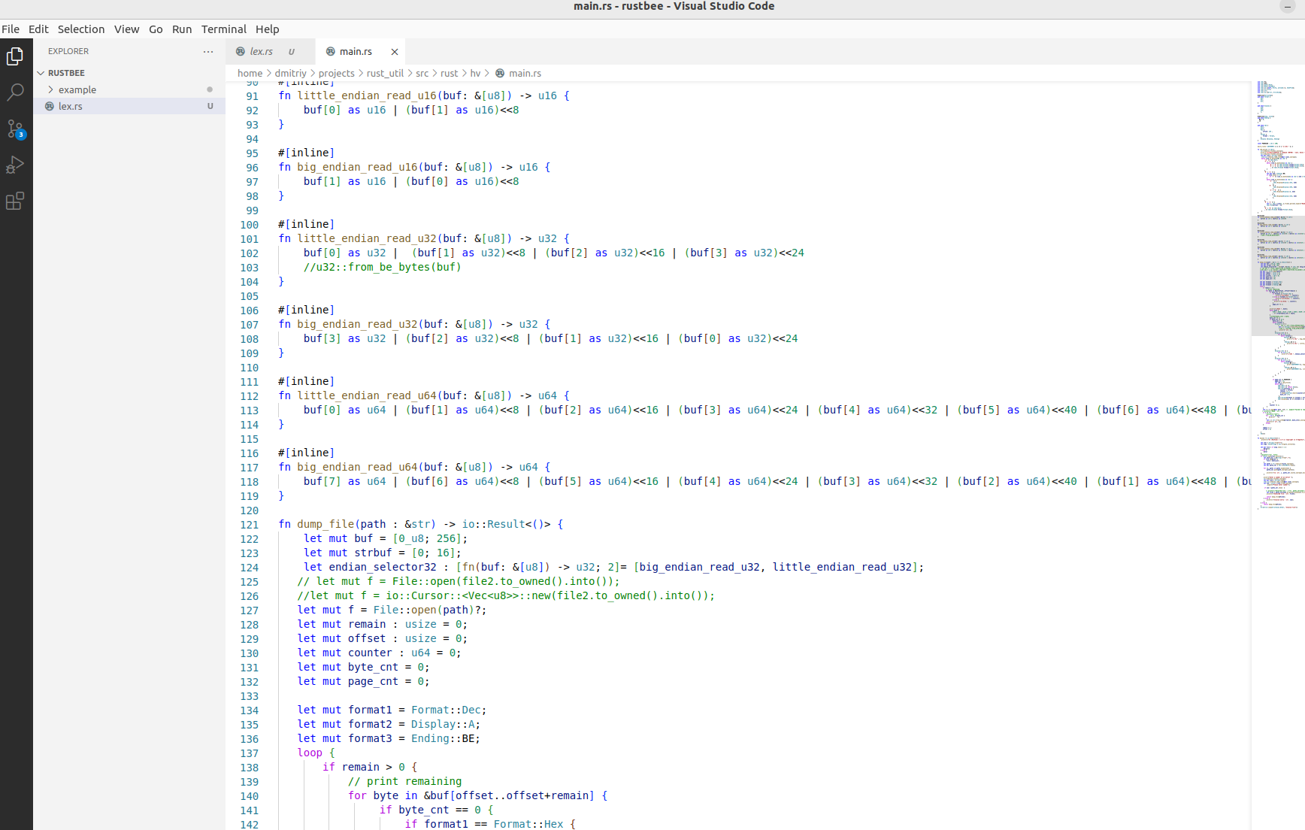
Rust vs Kotlin vs Swift vs C++

You may wonder - where is Java? Somehow Java is mostly like FORTRAN now. Yes, it is still supported but who cares?
Rust
It is still actively developing language although it’s already reached 1.67 milestone. Generally an idea was to provide a replacement for C++ with a modern syntax and without a buffer overflow or a dead pointer problems. Rejecting OOP features reduces a number of mistakes connected with understanding the code.
Kotlin
It is a Java replacement with modern syntax helping to make the code concise and effective. Current version is 1.7.20. It is also actively developed language making programming on it a bit uncertain, because your code will be likely outdated just in 6 months.
Swift
It is also actively developing language, although issuing new versions is a bit slowering now. The current version is 5.7. It is like 1.57, if to translate it to Kotlin/Rust form. Although Swift is used mostly for Apple development, it isn’t successor of Objective C. It is a completely new language, although still can coexist with C++ and Objective C code.
C++
Why this grandfather is still there? Most of system and performance programming is still in C++. The language is quite transforming, so current edition is C++20, and C++23 is planned to be out soon. If you compare C++ coding in 1995 to C++ in 2022, more likely you can think it was done in completely different languages.
Purpose
My blog won’t show you advantage of any language, or help to select one. It will show a difference when you need to frequently switch from one to another language as a part of your work responsibilities, sometimes several times a day. I will focus only on major features of every language, since switching between different language codebases mostly required for fixing bugs. However provided information is useful for many other purposes including selecting a language for a new project.
I will start from:

Defining variables
The reserved word let is used in Rust. Rust considers that all variable values can’t be changed after declaration, so you need to specify mut qualifier if you intend to change the value. Rust as all other mentioned here languages is strongly typed. It means that declaring a variable also declares its type and it can’t be changed after. However, a compiler will try to guess a type based on first assigned value. It is called the inferring. You can explicitly specify type especially for cases when auto detection isn’t possible or wrong. Rust doesn’t consider a variable without a value, so no null or undefined variables are possible.
Kotlin follows Rust guide line for variables. A mutable variable has to be defined as var, otherwise val. Inferring is also used for guessing a type. Undefined variables are impossible, but null are. If null value possible then many operations will require a specific check as using ?. A chance of getting NullPointerException is minimized.
Swift uses var for mutable variables, otherwise let. Types are guessing using inferring. Swift makes lot efforts of catching attempts using nil (not initialized) values. So be prepared to add extra checks or using ? at the end of statements. The behavior is very similar to Kotlin.
If C++ was staying apart requiring defining a type, then later modifications are also using inferring with keyword auto. However you have to play with const modifiers to emphasize immutability. There is no check that a variable is initialized. So programming in C++ requires more efforts.

An execution flow
If you do a programming for 10 or more years, then more likely you use an if/else construction. The condition of if doesn’t require parenthesis in Rust and Swift because curly brackets are required for execution blocks. However the modern style programming, if it is still imperative, based on heavily using a switch like construction. It is called match in Rust. Unlike if/else, you have to explicitly cover all variants. It reduces a chance that some condition is overlooked and then program works incorrectly in some cases. There is no fall through case, which is another source of common mistakes. Condition for every case can be specified as a pattern increasing flexibility of the code. Multiple conditions can be grouped using |.
Kotlin provides even more flexible construction as when. It allows completely to drop the if/else statement. Defining an else case is required, unless all possible cases are already covered.
Swift is more conservative keeping switch, however you can use a type and other attributes of a switch variable in cases. There is no fall through, unless you explicitly specify that.
No big changes are for switch in C++, so more likely you won’t get advantage of the new programming style.
As an action separator, Rust uses =>, Kotlin →, and : used by the rest.
One form of an if statement is still there, for all languages, but C++. It is if let, giving a possibility of a normal work or/else indicate an error.
Using statement separator ‘;’ is required in Rust and C++. Kotlin and Swift are okay with a line separator for that. Rust has a strange exception for last return statement, return and ‘;’ can be omitted together.

Loops
Rust doesn’t have loops with a traditional begin value, a stop condition and every iteration change. If you need all these parts, then you can use the loop with own implementation of the rest. However Rust gives a smart form of the for in loop. The while loop has condition at the beginning. Kotlin has a very similar for in loop. The while loop has a post loop execution condition form in addition. Swift has not much difference from siblings, and can use tuples as in Rust to get index or other information in for in variant. C++ keeps the traditional form of for and while loops.

Exceptions
They are supported in Kotlin, Swift and C++. Rust allows only check that the last operation was successful. You should use unwrap if do not plan to check errors. Kotlin and Swift also provide a finally block, as finally in Kotlin and defer in Swift. Swift uses do for marking a try section, the rest uses try. You should rely on programming style not based on the feature in Rust and C++.

OOP
Rust isn’t OOP language and you should use a methods composition in it. However interfaces supported in a form of traits. They called protocol in Swift and pure virtual class in C++. The rest languages support OOP with most advanced form in C++ as the multiple inheritance. Methods will be final in Kotlin by default. You should stay away from OOP if plan to develop a project in languages including Rust.

Lambda and closures
Modern programming style relies on using the functional programming. All languages provide a great support for that. Most tasks are solvable using the following sequence of actions:
range – filter – map – reduce
The above operations are standardly provided and you need only customize them for a particular task. Every operation in the chain is defined as a lambda. It is like a procedure, but without calling header and defined inline. It can use variables from surrounding block named as a closure. Rust separates passing parameters in a lambda using wrapping |. If there are no parameters, then two || have to remain anyway. If a lambda is a single operator then {} are not required. Body should be separated from parameters using → , however not required for a single statement. It is better to check with the documentation all possible variants. Kotlin uses much simple syntax requiring only → between parameters and a lambda body. Swift doesn’t list parameters for a lambda, however they can be accessed inside using $N notation, where N is a parameter order number. Lambdas can look very tricky in Swift, for example like only < for comparison code required by sorting algorithms. Again C++ provides more detailed control of lambda parameters and access of variables in a used closure.

Standard data structures
Structure
Obviously it is supported by all languages. Structures are associated with a certain data object in OOP languages as well. Rust can use a set of method associated with a data structure, however no inheritance and no polymorphism is there.
Enum
Enum has a much wider use now. Variants of it can be different structures in addition to just ordinary values.
Tuple
Rust has a native support of tuples, and they are also preferable data structures in many cases. There no tuples for Kotlin, since it uses JVM for the underneath implementation. First versions Kotlin had a simulation of tuples as a pair and a triple data structures, but then were depreciated in favor of data objects. Swift supports tuples as native structures, however Swift considers them as a temporary storage to return multiple objects from a function call, or using a storage for an index and value in loops. C++ doesn’t have tuples, but a tuple like structure can be used from the standard library.
Array/vector
It is a fundamental data structure. Major difference of array and vector that array has a fixed size requiring a reallocation in case of changing a size of the array, when a vector size is dynamic. Slicing mechanism is very helpful to access a certain part of an array, and even there is no requiring additional memory allocation and copying in most cases. Standard algorithms as sorting, searching, reversing, merging and so on are provided by a standard language library.
Map
It is also a fundamental data structure allowing to access elements of map using a key. Underneath implementation is based usually on a hash table.
String
Most of programs use string in one or other form. All languages support strings as a traditional ASCII form as a modern multi byte form. A regular expression is supported by all languages helping to categorize a string.

Memory management
This is an interesting aspect making programming in every language essentially different. Rust is based on RAII (Resource Acquisition Is Initialization) and an ownership. Every data allocation has only one owner. Ownership can be moved to another owner. Multiple consumers can borrow a reference to data as long as the current owner is alive. A special owner as a reference counter can be allocated. Such owner remains alive as long as the reference counter is greater than zero. When access to data borrowed, & is used to emphasize that.
Kotlin utilizes a standard VM garbage collector and no special actions are required. Swift model is based on a reference counter, so generally a programmer also freed from an extra work. However special actions should take in place if cyclic references are used, or data should get a global scope. C++ offers manual allocation and freeing a memory. Later versions encourage a user to utilize RAII model. It is similar to Rust, however here is no strong ownership rule.
Only Rust (as non OOP) has no mechanism of a constructor/destructor. However new or default method has to be defined helping to determinate a size of required memory for data and also how it has to be initialized. Kotlin has no a clear destructor, because there is no a programmer controlled time of destroying an object. Therefore an interface AutoCloseable or Closeable for objects requiring a destructor like functionality has to be defined. Kotlin provides standard method the use which frees a developer from an explicit specifying try/finally block. A destructor is defined as deinit in Swift. C++ provides it in a form ~classname(). It has to be virtual if a chain destructors of all parent classes has to be called.

Multi tasking
The feature is a standard for Rust, Kotlin and Swift. However it may require 3rd party library for C++ like Boost unless C++ 13 and up is used, where a multi threading support included in std. You can initiate a native OS thread in Rust, and join its execution if required. A good set of standard concurrency primitives including a mutex and Arc (atomic reference counter) are provided. Lambdas have to use move qualifier to be executed asynchronously keeping in mind safety. Kotlin uses coroutines in addition to concurrent Java library. Certainly it will gets advantage of virtual threads in JVM version 19 and up. Swift uses an own classes set to spawn threads, provide synchronization and communication between them.

Macros
Rust has a good macro languages helping to reduce a boilerplate code and reduce coding efforts for such general things as a printing. There is no macro language in Kotlin. Swift supports some macro definitions helping to configure code for a different environment or stages. C++ gives most advanced macro processor.

Other aspects
Although many languages consider a certain coding style, it got implementation in a compiler only in Rust. The compiler will give you a warning if you selected a name of a variable not complaining with the code standard. Rust also considers some name style, as reserved for a certain purpose, for example names with _. Swift is a kind of opposite and you can use any Unicode symbols for variable names.
Conclusion
Although every language has a certain uniqueness, overall possibilities are similar and the major difference appears only in a memory management. So a developer has to focus on this aspect at learning and using a new language.

